Y2Q1W6

The Temple
Show: Some nature pictures
Ask: Who made these things?
Ask: Do you think God likes beautiful things?
Say: King David wanted to build a beautiful temple for God, but God told him that his son Solomon would build it.

Bible Story

Sing some songs.

Say: I have some pictures here. Which picture do you think would be a better way for Church to be?

Return to tables
Memory Verse: Fill in the blanks and then say the memory verse on the colouring page.

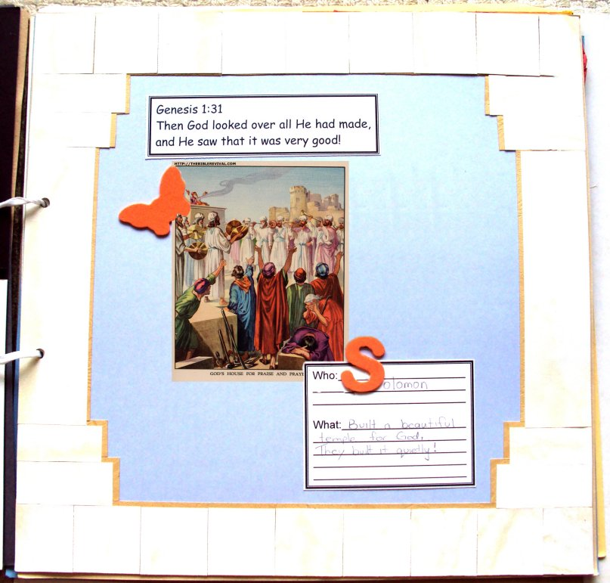
Say: Every week this term we will be making a page to add to a scrapbook. Since we didn't do one last week we have two to do this week.

Craft:
- Choose a coloured cardboard
- Glue/tape the marble coloured squares around the border
- Stick on the photo, verse, who/what card, foam letter and insect.

Discuss the following depending on age, interest and time:
Does God cares if our Church is really expensive, or not? Does it have to have golden walls?
Does God care how our Church looks? Clean / dirty, broken / well repaired etc.
Looking around, can you see anything that could be done nicer?
How can you act / what can you do in Church to make it better?

Primary / Junior / Teen Conclusion:
Discuss what your table might do as a special project for our Church. (For example: Clean or renovate a particular area, make a new sign for inside or outside, covering for back cupboards, picture for above cupboards, help with Church library.)

Make Plans: What / when / where / how etc.

Primary / Junior / Teen: This term, those of you who would like to get a Bible to take home, may take one of the orange Commandment pages and add to your book. Each week you come you can put a sticker on it and when it is all complete we will get you a Bible to take home and keep.

Finish with prayer at each table.

